Report On

Title of the Course Project

Submitted in partial fulfillment of the requirements of the Course project in

Semester III of Second Year Artificial Intelligence and Data Science

by

Saloni Sutar (Roll No. 58)

Sakshi Patil (Roll No.44)

Rutuja Pednekar(Roll No.47)

Supervisor

Prof. Mrs. Sejal D’mello



**University of Mumbai**

**Vidyavardhini's College of Engineering & Technology**

**Department of Artificial Intelligence and Data Science**

**(2023-24)**

**Vidyavardhini's College of Engineering & Technology**

**Department of Artificial Intelligence and Data Science**

**CERTIFICATE**

This is to certify that the project entitled “Circle Design” is a Bonafide work of "Saloni Sutar (Roll No. 58), Sakshi Patil (Roll No. 44), Rutuja Pednekar (Roll No. 47)" submitted to the University of Mumbai in partial fulfillment of the requirement for the Course project in semester III of Second Year Artificial Intelligence and Data Science engineering.

**Supervisor**

|  |  |  |
| --- | --- | --- |
| Prof. Mrs. Sejal D’mello |  |  |
|  |  |  |
| Dr. Tatwadarshi P. N.  Head of Department |  |  |

**Table of Contents**

**Pg. No**

|  |  |  |  |
| --- | --- | --- | --- |
| Chapter No |  | Title | Page No. |
| **1** |  | **OVERVIEW** | **1** |
| **2** |  | **PROGRAM AND OUTPUT** | **4** |
| **3** |  | **EXPLANATION** | **7** |

1. **OVERVIEW :**

In this project, you will develop a computer program that draws a series of concentric circles on a graphical window or canvas. The project will involve using a programming language or graphics library, such as OpenGL, DirectX, or a web-based framework like HTML5 Canvas or WebGL.

1. User Interface: Depending on your choice of platform, design a simple user interface where users can specify parameters like the number of circles, their radii, colors, and position.
2. Graphics Library: Choose a suitable graphics library or framework to render the concentric circles. You'll use functions or methods from the library to draw and manipulate the circles.
3. Concentric Circles: Write code to draw the circles. To create concentric circles, you can start with the center circle and then draw subsequent circles with increasing radii. The number and size of circles can be specified by the user.
4. Colors: Allow users to select colors for the circles. You might provide a color palette or a color picker.
5. Animation (Optional): For an advanced project, you can add animation effects like rotation or scaling to the concentric circles.
6. Save/Export: Give users the option to save or export the resulting image, possibly in different formats (e.g., PNG, JPEG).

Once you've completed the basic project, you can consider extending it with more advanced features, such as:

Interactive resizing and dragging of circles.

Adding other geometric shapes, like ellipses or lines.

Implementing more complex rendering techniques, like shading and textures.

This project is an excellent way to learn about computer graphics, user interface design, and interactive programming. It can be tailored to various skill levels, from beginner to advanced, depending on the complexity and features you choose to implement.

1. **PROGRAM AND OUTPUT :**

#include <stdio.h>

#include <conio.h>

#include <graphics.h>

#include <dos.h>

void main()

{

clrscr

{

int gd=DETECT,gm,i;

initgraph(&gd,&gm,"C:\\TURBOC3\\BGI");

for(i=0;i<=100;i++)

{

circle(319,219-i,20+i);

circle(319,219+i,20+i);

circle(299-i,239,20+i);

circle(339+i,239,20+i);

delay(100);

}

getch();

}

}

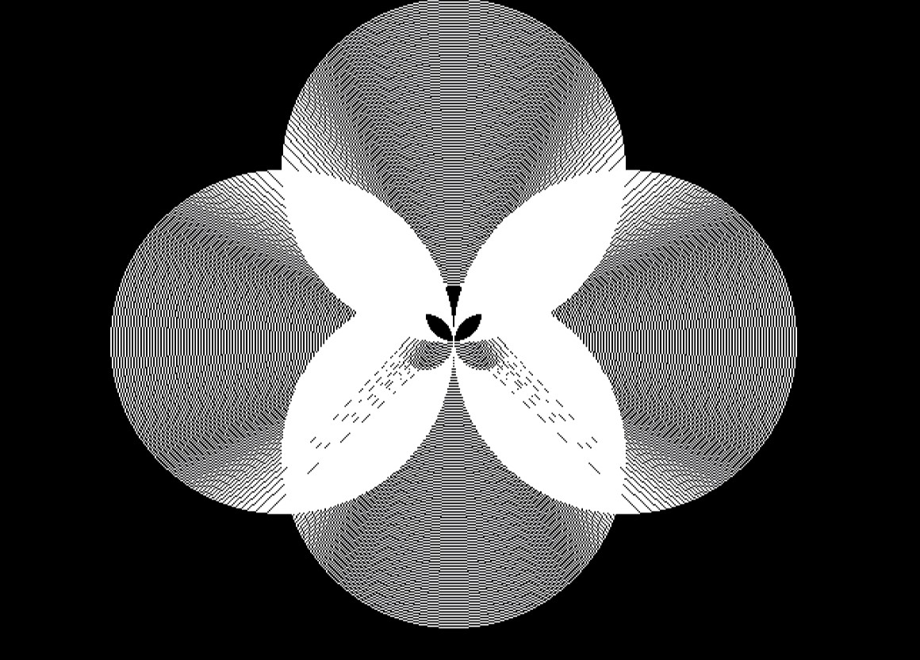

1. **EXPLANATION :**

A computer graphics circle drawing project is a programming task that involves creating a series of circles, where each circle having different center point. These circles are arranged in such a way that they appear to be nested within one another, forming a series of concentric circles.

1. Graphics Library or Framework:

You will typically use a graphics library or framework in your chosen programming language to create and render the concentric circles. Common libraries include OpenGL, DirectX, HTML5 Canvas, or WebGL. These libraries provide functions and tools for rendering graphics on a screen.

2. User Interface:

Depending on the complexity of your project, you may create a graphical user interface (GUI) that allows users to interact with your program. The interface might include options for setting parameters like the number of circles, their radii, colors, and other visual settings.

3. Drawing Concentric Circles:

To draw concentric circles, you'll typically use a loop to draw multiple circles, each with a slightly larger radius than the previous one. The center point remains constant for all circles. You can choose various methods to draw these circles, such as using functions to draw ellipses or circles, or by specifying the coordinates and radii of each circle manually.

4. User Interaction:

If you have a user interface, you'll need to handle user interactions. For instance, you might allow users to click and drag circles, change their radii, or dynamically change colors. These interactions can make your project more engaging and interactive.

5. Rendering:

Utilize the graphics library's rendering capabilities to display the circles on the screen. Ensure that the circles are drawn accurately, appear concentric, and adhere to the user's specified settings.

6. Optional Features:

Depending on your project's complexity, you can add features like animation, where the circles can move, grow, or change over time. You might also allow users to export the resulting image to a file or adjust the rendering quality.

7. Testing and Debugging:

Thoroughly test your program to ensure that it functions as expected. Verify that the concentric circles are drawn accurately and that user inputs are correctly processed. Debug and fix any issues you encounter during testing.

In summary, a computer graphics circle drawing project involves using a graphics library or framework to create an interactive or static application that draws a series of circles. The user can customize various aspects of the circles, such as their number, size, and color. This project is an excellent way to learn about graphics programming, user interface design, and user interaction in a graphical context.